CMSC 204
Project5: Morse Code Converter
Assignment Overview
In this project, you will build a Morse Code Converter Utility. The converter uses a generic linked binary tree with generic TreeNode objects to translate Morse Code into English text.
You will implement the core classes needed to build and traverse the Morse Code tree. There is no GUI requirement for this assignment, though a small GUI is provided for testing purposes.
Learning Objectives
- Implement and work with generic classes.
- Build and traverse a linked binary tree for data conversion.
- Develop a utility class with static methods.
- Practice unit testing with JUnit.

Provided Classes
You are supplied with the following interfaces and Javadoc (not listed here, but assumed available in your starter files). These define the public methods required to pass the provided JUnit tests.
- LinkedConverterTreeInterface<T> – Defines the tree operations.
- GUI is supplied for demonstration but is not part of grading.
Required Classes
Data Element - TreeNode
This generic class is used in the MorseCodeTree classes. The class consists of a reference to the data and a reference to the left and right child. Follow the Javadoc that is provided. The Javadoc only lists those public methods that are required to pass the Junit tests. You may add any private methods you need for your design.

Data Structure – MorseCodeTree
A generic linked binary tree which inherits from the LinkedConverterTreeInterface. The class uses an external generic TreeNode class parameterized as a String: TreeNode<String>. This class uses the private member of root. Nodes are added based on their morse code value. A ‘.’ (dot) means to traverse left and a ‘-‘ (dash) means to traverse right. The constructor will call the method to build the tree. Follow the Javadoc that is provided. The Javadoc only lists those public methods that are required to pass the Junit tests. You may add any private methods you need for your design.
Utility class - MorseCodeConverter
The MorseCodeConverter contains a static MorseCodeTree object and constructs (calls the constructor for) the MorseCodeTree.
This class has two static methods convertToEnglish to convert from morse code to English. One method is passed a string object (“.-.. --- ...- . / .-.. --- --- -.- ...”). The other method is passed a file to be converted.
These static methods use the MorseCodeTree to convert from morse code to English characters. Each method returns a string object of English characters.
There is also a static printTree method that is used for testing purposes – to make sure the tree for MorseCodeTree was built properly.
Use the Javadoc provided to make sure that your MorseCodeConverter class follows the method headers so that the MorseCodeConverter Test will run correctly.

Project Details
This is a table for the conversion from Morse Code to alpha letters.
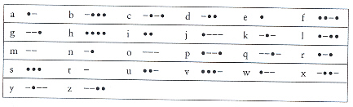
Building the MorseCodeTree (method buildTree)
Your MorseCodeTree is a 5 level tree. Insert a mapping for every letter of the alphabet into the tree map. The root is a TreeNode with an empty string. The left node at level 1 stores letter ‘e’ (code ‘.’) and the right node stores letter ‘t’ (code ‘-‘). The 4 nodes at level 2 are ‘i’, ‘a’, ‘n’, ‘m’ (code ‘..’, ‘.-‘, ‘-.’, ‘—‘). Insert into the tree-by-tree level from left to right. A ‘.’ will take the branch to the left and a ‘-‘ will take the branch to the right. This is the structure of the tree.
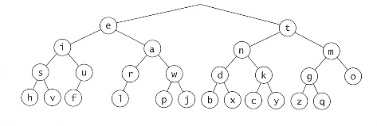

Using the MorseCodeTree
Use the MorseCodeTree to convert Morse Code to English by taking the code and finding it’s corresponding English letter by traversing the MorseCodeTree, ‘.’ branches to the left and ‘-‘ branches to the right. The code ‘.--.’ would branch to the left, then to the right, then to the right, then to the left to Fetch the letter ‘p’. Each letter is delimited by a space (‘ ‘). Each word is delimited by a ‘/’.

Some suggestions
There is a morse code translator at: http://morsecode.scphillips.com/jtranslator.html
This will help you build files and test cases for your JUnit Tests.

Examples:
Hello World

How do I love thee let me count the ways
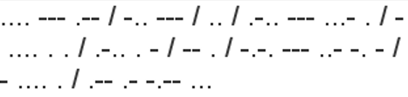

Testing Notes
The provided GFA (Good Faith Attempt) JUnit tests represent the minimum requirements to validate the basic functionality of your project. If the project due date has passed, your submission must pass these tests in order to be considered for course credit.
In addition to the GFA tests, any GUI code and public JUnit tests are provided to assist with basic verification of your implementation. However, these do not cover all functionality. You are expected to design and run additional tests to ensure the full correctness and robustness of your project.

Deliverables
Before submitting your project, ensure your code is free of syntax errors. Submissions that do not compile will receive zero points.

Design Documents UML and/or Pseudo-Code

Implementation Only submit files that you have created or modified, do not submit unmodified files that were provided in the project download. Place all your .java files inside a src folder. Include the entire doc folder with Javadoc for your own classes.

Summary Write-Up A 2-3 paragraph write-up (eg.LearningExperience.doc)

Submission Packaging
You will submit two compressed .zip files:
Main Project Files All student created or modified project files and data:
Filename LastNameFirstName_AssignmentX.zip
src/ directory containing .java files created or modified by the student
doc/ directory containing student created Javadoc files
LearningExperience.doc reflection and write-up
Design Documents all design related documents

MOSS files Only the student created or modified source code files
Filename LastNameFirstName_AssignmentX_Moss.zip
source files only the .java files created or modified by the student
Grading Rubric
Criteria | Points
MorseCodeTree implementation | 45%
TreeNode Implementation | 10%
MorseCodeConverter Implementation | 45%
JUnit student-written tests | -5%
Design and Reflection write-up | -10%
Code style, documentation, and Javadoc (If not provided). | -5%

